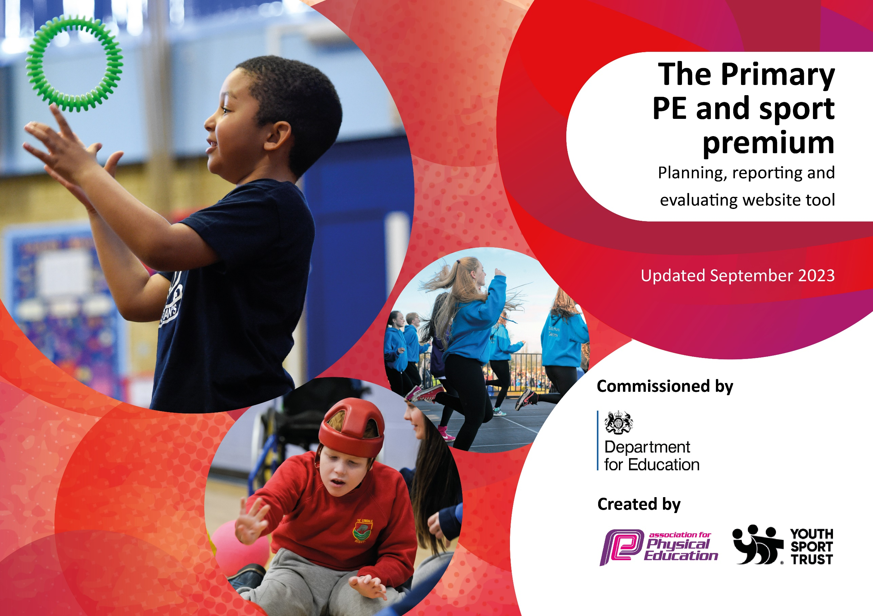

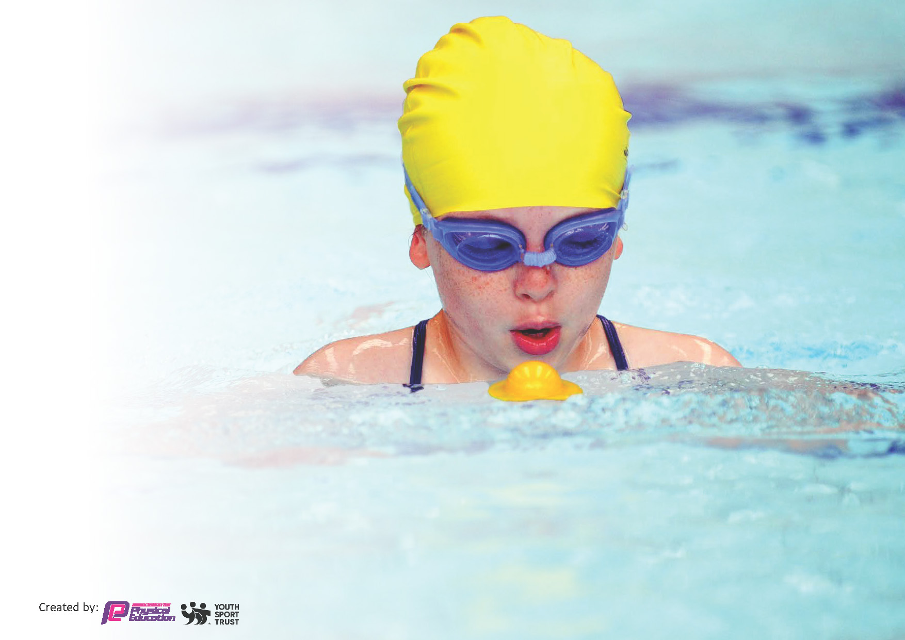
This template can be used for multiple purposes:
by:
- It enables schools to effectively plan their use of the Primary PE and sport premium
- It helps schools to meet the requirements (as set out in guidance) to publish information on their Primary PE and sport premium
- It will be an effective document to support Ofsted inspections enabling schools to evidence progress in Physical Education (PE) and evidence swimming attainment, which forms part of the PE National Curriculum. We would recommend schools consider
the Intent, Implementation and Impact of any spend, as examined within the Education Inspection Framework.

It is important that your grant is used effectively and based on school need.

Schools must use the funding to make additional and sustainable
improvements to the quality of the PE, School Sport and Physical Activity (PESSPA)
they offer. This means that you should use the Primary PE and sport premium to:

- Build capacity and capability within the school to ensure that improvements made now will benefit pupils joining the school in future years
- Develop or add to the PESSPA activities that your school already offers.

The Primary PE and sport premium should not be used to fund capital spend projects; the school’s core budget should fund these. Further detail on capital expenditure can be found in the updated Primary PE and sport premium guidance.

The Primary PE and sport premium guidance, outlines 5 key priorities that funding should be used towards. It is not

necessary that spending has to meet all the key priorities, you should select the priorities that you aim to use any funding towards.

Although completing this template is not a requirement for schools, schools are required to publish details of how they spend this funding. Schools must also outline what the impact this funding has had on pupils’ PE and sport participation and attainment and how any spending will be sustainable in the future. All funding must be spent by 31st July 2024.

The Department for Education has worked closely with the Association for Physical Education (afPE) and the Youth Sport Trust (YST) to develop this template and encourages schools to use it. This template is an effective way of meeting the reporting requirements of the Primary PE and sport premium.
Review of last year’s spend and key achievements (2022/2023)

We recommend you start by reflecting on the impact of current provision and reviewing your previous spend.

Development of local Sports Festivals. | Opportunities for children to take part in new and varied sports with coaching and competition provided. | New sports festivals devised in handball, basketball, hockey.
Enhanced sports coaching within school through use of specialist coaching for all year groups. | A wider range of activities introduced including handball and badminton across the age ranges and using new equipment purchased using PE Premium. | New after school clubs also created and increased participation rates in sport such as fencing.
Sports Leaders received enhanced training. | Opportunities to developing sporting abilities during the school lunch/playtimes was increased | The timetable was expanded to increase the amount of football all year groups can play at lunch/play.
Return of the South Broxtowe football and netball leagues and competitions. | Post-Covid re-introduction of leagues giving children regular sporting fixtures and the end of year tournament, increasing competitive sports. | Widely attended events throughout the year also encouraged parental engagement.

Key priorities and Planning 2023-24
This planning template will allow schools to accurately plan their spending.

Action – what are you planning to do | Who does this action impact? | Key indicator to meet | Impacts and how sustainability will be achieved? | Cost linked to the action
Continue to develop enhanced sports coaching within school through use of specialist coaching for all year groups.  Supporting CPD for all staff coaching and teaching alongside the specialist. | All children will receive varied and specialized sports coaching, including multi-skills in EYFS and KS1 to improve fine motor skills.  Primary generalist teachers uplevel and improve own understanding of coaching techniques and new sports. | Key indicator 2 -The engagement of all pupils in regular physical activity  Key indicator 1- Increased confidence, knowledge and skills of all staff in teaching PE and sport  Key indicator 4- Broader experience of a range of sports and activities offered to all pupils | Specialist sports coaches deliver 4 different sessions per week, covering 8 classes per half term. All children receive several courses of specialist coaching per year.  This also helps deliver CPD to all staff who coach alongside the specialist | This uses the majority of the PE premium. 3 specialist coaches delivering 4 different sessions each week = c.£17,000
Expand range of inter-school sports competitions | South Broxtowe Sports Association increased range of competitions this year to include a girls’ football league and football tournament, organised by member of staff in school. | Key indicator 5- increased participation in competitive sport | Uptake in girls’ football increased substantially. Competitive matches played and first girls’ tournament participated in. | No additional cost as participation in activities and competitions is free to all, delivered and organised by members of staff.
Initiate girls’ football squad and team. | Girls in Y5 and Y6 have a new opportunity for training, coaching and competitive sport. | Key indicator 5- increased girls’ participation in competitive sport | Uptake in girls’ football increased substantially. Competitive matches played and first girls’ tournament participated in. | No additional cost as participation in training provided by members of staff in lunchtime/after school.
New sports Leaders to receive training | Greater range of refereeing and leading opportunities by expanding the range of children from Y6 to Y5/6. Increased engagement in football by girls.  Children involved in netball have designated equipment to play and train with at lunch and breaktimes. | Key Indicator 3- The profile of PE and sport is raised across the school as a tool for whole school improvement  Key indicator 4- Broader experience of a range of sports and activities offered to all pupils | More pupils meeting their daily physical activity goal, more pupils encouraged to take part in PE and Sport Activities. | No additional costs as children trained as leaders during breaktimes/lunchtimes by teachers in Y5/6.
Expand lunch or pre-school sport sessions/activities for pupils. | Teaching staff, TAs - as they need to lead the activity pupils – as they will take part. | Key indicator 2 -The engagement of all pupils in regular physical activity  Key indicator 4- Broader experience of a range of sports and activities offered to all pupils | More pupils meeting their daily physical activity goal, more pupils encouraged to take part in PE and Sport Activities. Run by staff as part of their daily timetable. | No additional costs as sessions run by TAs after staffing changes.

Key achievements 2023-2024
This template will be completed at the end of the academic year and will showcase the key achievements schools have made with their Primary PE and sport premium spending.

Activity/Action | Impact | Comments
- Cricket coaching and CPD for staff. Cricket continued for Y2, Y5 and Y6.  - Premier Sports specialist coaching and CPD for staff– (JAtk). Broad range of sports coaching across the entire school.  - Zenith Sports specialist coach (MT)- broad range of sports taught across the school- specialist coaching plus CPD for staff.  - New girls’ football kit purchased.  - New playground equipment.  - Introduce before school breakfast sports club, 5 days a week. (GE)  - Introduce breakfast Dance club (YH)  - New Hive coloured t-shirts for PE lessons and inter hive competition purchased at the end of the year. | 1.Whole class quality cricket coaching, every Monday during the year and including After-School Club to develop competitive cricket, with a view to participating in tournaments. (Key indicator 5- increased participation in competitive sport) These sessions also act as CPD for staff- teacher plus TA where appropriate- as all children participate in curriculum hours. Key indicator 4. Broader experience of a range of sports  2.Josh coaches a breadth of sports across the entire school. Foundation and KS1 received targeted multi-skills sessions to help improve fine motor skills and introduced new sports- handball- for greater variety of exposure including After School Club Y2. Further up the school, Josh ran gymnastics sessions and after school club for Y3 and the fencing club in Y6.  3.Broad range of curriculum sports taught, including further multi-skills sessions in FDN/KS1, football and athletics in LKS2. After school clubs delivered to Y3, Y4 and Y5 throughout the year.  - New girls’ football team competed in league and highly successful inaugural end of year tournament. (DG/KL) (Key indicator 5- increased participation in competitive sport and Key indicator 4. Broader experience of a range of sports- new girls football team  - The children have access to fitness equipment each playtime and lunchtime. Basketball, netball, table tennis, football, space hoppers, throwing and catching  - 15 children have taken part in Y3/4/5 sports clubs before school, 5 days a week.  - 7. YH leads dance club for up to Y1 and Y2 children. These groups included many children who would not otherwise access an after-school club.  - These will be used in regular inter-hive sporting competitions in future years. | 1. Total cost of 6 half terms of weekly curriculum sessions, plus after school clubs= £5,000. (JAsh). (Key indicator 4. Broader experience of a range of sports)  - £5242.50 (Key indicator 4. Broader experience of a range of sports)  - £6380.18 for two afternoon’s coaching and one ASC. (Key indicator 4. Broader experience of a range of sports)  - Cost £187.00 for kit. (Key indicator 5- increased participation in competitive sport) Uptake in girls’ football increased substantially. Competitive matches played and first girls’ tournament participated in.  - £1131.21 (Key indicator 2 -The engagement of all pupils in regular physical activity)  - More pupils meeting their daily physical activity goal, more pupils encouraged to take part in PE and Sport Activities.  - Y1 and Y2 dance club also performed at the Summer Fair. No extra cost- TA timetables adjusted accordingly.  8.Cost £700 for 442 shirts, one for every child in school to participate. (Key Indicator 3- The profile of PE and sport is raised across the school as a tool for whole school improvement)

Swimming Data
Meeting National Curriculum requirements for swimming and water safety.
Priority should always be given to ensuring that pupils can perform safe self-rescue even if they do not fully meet the first two requirements of the National Curriculum programme of study

Question | Stats: | Further context  Relative to local challenges
What percentage of your current Year 6 cohort can swim competently, confidently and proficiently over a distance of at least 25 metres? | 75% | Children swam in Year 5 this academic year, so numbers based on previous year’s swim sessions, which do not include a number of new starters within the year group this year. This notwithstanding, the percentage increased from 69% to 75%. Approximately 90% of those children present in Y5 achieved the distance successfully.
What percentage of your current Year 6 cohort can use a range of strokes effectively [for example, front crawl, backstroke, and breaststroke]? | 69% | As above.

What percentage of your current Year 6 cohort are able to perform safe self-rescue in different water-based situations? | 90% | All children present during swim sessions participated in and demonstrated safe self-rescue. New starters the only children not to take part in this.
If your schools swimming data is below national expectation, you can choose to use the Primary PE and sport premium to provide additional top-up sessions for those pupils that did not meet National Curriculum  requirements after the completion of core lessons. Have you done this? | Yes/No | Top-up not available this year.
Have you provided CPD to improve the knowledge and confidence of staff to be able to teach swimming and water safety? | Yes/No | CPD through supporting the activities within the swimming pool, observing Nottingham City Schools coaches and JC ASA qualified swim teacher.

Signed off by:

Head Teacher: | Janine Waring
Subject Leader or the individual responsible for the Primary PE and sport premium: | Dan Gooch, PE Lead
Governor: | Katherine Calder
Date: | 31/7/24

